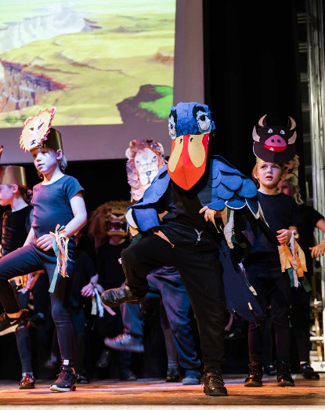

**Open Afternoon**

For prospective pupils and parents

Tuesday 20th September

Hourly tours starting at 1.30pm - 5.30pm

If your child is due to start Reception in **September 2023**, you are warmly invited to attend our Open Afternoon.

Take a tour of the school, meet the staff and find out more about Montalbo and what it can offer your child.

Alternative appointments can be arranged if required.

To book an appointment:

Call: 01833 637718

Email: montalbo@durhamlearning.net

Fairfield Road, Barnard Castle, DL12 8TN

Montalbo Nursery

and Primary School

Collaborate

Endeavour

Inspire